**Task12-Gemini**

**Flexbox Layout Model and Responsive Design**

**Flexbox** is a CSS layout module designed to provide a more efficient way to arrange items in a container. It's particularly useful for creating flexible and responsive layouts, as it allows elements to automatically adjust their size and position based on the available space.

**Key Concepts of Flexbox**

* **Flex Container:** The parent element that contains the flex items.
* **Flex Items:** The child elements within the flex container.
* **Flex Axis:** The main axis along which flex items are arranged.
* **Cross Axis:** The axis perpendicular to the flex axis.

**How Flexbox Simplifies Responsive Design**

* **Automatic Adjustments:** Flexbox automatically distributes space among flex items based on their flex-grow, flex-shrink, and flex-basis properties. This makes it easy to create layouts that adapt to different screen sizes.
* **Flexible Alignment:** Properties like justify-content and align-items allow you to control the alignment of flex items along the flex axis and cross axis, respectively.
* **Direction Control:** The flex-direction property determines the direction in which flex items are placed within the container. This can be used to create both horizontal and vertical layouts.

**Example: A Responsive Card Layout**

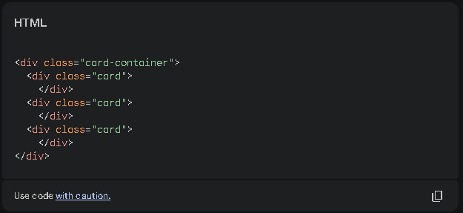

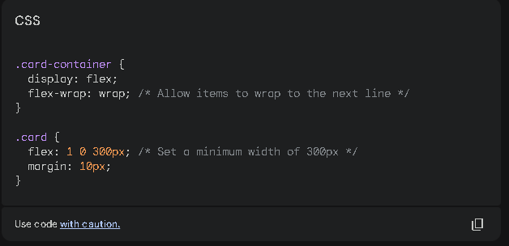

In this example:

* **.card-container** is set to **display: flex** to establish it as a flex container.
* **.card** elements are flex items that will automatically adjust their width based on the available space.
* **flex-wrap: wrap** allows the cards to wrap to the next line when the screen width is too small.

**Adjusting the Layout with Properties**

* **justify-content:** Controls the alignment of flex items along the main axis.
  + **space-between:** Spaces items evenly, with extra space on the sides.
  + **center:** Centers items along the main axis.
  + **flex-end:** Aligns items to the end of the main axis.
* **align-items:** Controls the alignment of flex items along the cross axis.
  + **center:** Centers items vertically.
  + **flex-start**: Aligns items to the top of the cross axis.
  + **flex-end:** Aligns items to the bottom of the cross axis.
* **flex-direction:** Determines the direction in which flex items are placed.
  + **row:** Items are placed horizontally.
  + **column:** Items are placed vertically.

By using these properties in combination, you can create a wide variety of responsive layouts that adapt to different screen sizes and orientations.